OH MY STARS, THIS IS IT – THE FINAL STAR!!
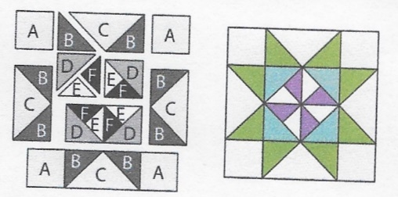
SEPTEMBER 2018 –MARTHA WASHINGTON STAR

Cutting Directions:
All blocks this year use a ¼ inch seam allowance and will be the same size: 12 ½ x 12 ½ unfinished.
From fabric provided with pattern:
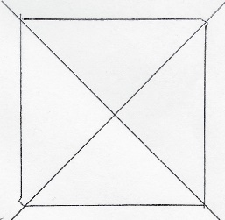
F Fabric: Cut one (1) 4 1/4 square, cut twice on the diagonal for 4 pieces
From Background fabric:
A Fabric: Cut four (4) 3 1/2” squares (corner squares)
C Fabric: Cut one (1) 7 1/4” square, cut twice on the diagonal for 4 pieces
E Fabric: Cut One (1) 4 1/4” square, cut twice on the diagonal for 4 pieces
From coordinating fabric:
B Fabric: Cut four (4) 3 7/8” squares, cut each once on the diagonal for 8 pieces
D Fabric: Cut two (2) 3 7/8” squares, cut each one once on the diagonal for 4 pieces
Sewing Directions: (refer to diagram on upper left)
- Sew two “B” pieces to a “C” piece. Repeat for four rectangles (outer Flying Geese)
- Sew an “A” piece to each side of two “B/C” Flying Geese rectangles for the outer top and bottom rows
- Sew an “F” piece to an “E” piece. Repeat to make four E/F pieces
- Following the diagram, sew a “D” piece to each E/F piece, then sew together for the center square
- Sew two “B/C” Flying Geese rectangles to opposite sides of the center square for the middle row
- Sew the three rows together
Congratulations, you’ve finished the Stars!
Now – how to set the blocks? It’s up to you! Bring your top to the October meeting for show and tell and to get your $10 voucher for the November “Beyond Boring Borders” workshop.

