OH MY STARS!
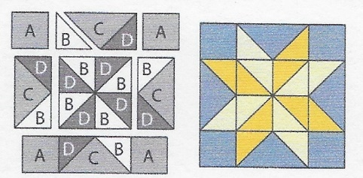
MAY 2018 –DIAMOND STAR

Cutting Directions:
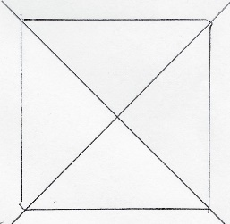
All blocks this year use a ¼ inch seam allowance and will be the same size: 12 ½ x 12 ½ unfinished.
From fabric provided with pattern:
C Fabric: Cut one (1) 7 1/4” square, cut twice on the diagonal for 4 pieces
From coordinating fabric:
D Fabric: Cut Four (4) 3 7/8” squares, cut each once on the diagonal for 8 pieces
B Fabric: Cut four (4) 3 7/8” squares, cut each once on the diagonal for 8 pieces
From Background fabric:
A Fabric: Cut four (4) 3 1/2” squares (corner squares)
Sewing Directions: (refer to diagram on upper left)
- Sew 4 “B” pieces to 4 “D” pieces, then sew together to make the center square of the block (you can also have created Half Square Triangles for these)
- Sew a “B” and a “D” to a “C”, being careful to follow the diagram. Repeat for 4 rectangles (Flying Geese)
- Sew an “A” piece to each side of two Flying Geese for the top and bottom rows
- Sew a Flying Geese piece to each side of the center square created by the B/D pieces.
- Sew 3 rows as noted in the diagram

Congratulations, you’ve finished Block 5 – Diamond Star!

