OH MY STARS!
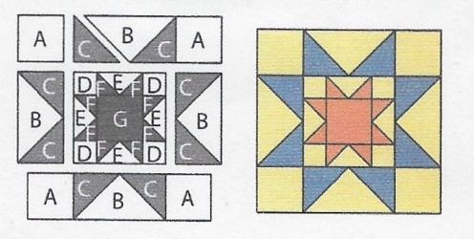
JUNE 2018 –DOUBLE SAWTOOTH STAR

Cutting Directions:
All blocks this year use a ¼ inch seam allowance and will be the same size: 12 ½ x 12 ½ unfinished.
LUCKY YOU– TWO pieces of fabric provided with pattern!
F Fabric: Cut four (4) 2 3/8” squares, cut each once on the diagonal for 8 pieces
G Fabric: Cut one (1) 3 ½ square
From Background fabric:
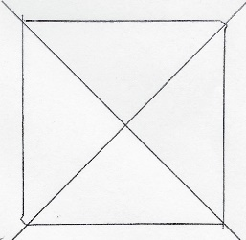
A Fabric: Cut four (4) 3 1/2” squares (corner squares)
B Fabric: Cut One (1) 7 1/4” square, cut twice on the diagonal for 4 pieces
From coordinating fabric:
C Fabric: Cut four (4) 3 7/8” squares, cut each once on the diagonal for 8 pieces
From coordinating or background fabric:
D Fabric: Cut Four (4) 2” squares
E Fabric: Cut One (1) 4 1/4” square, cut twice on the diagonal for 4 pieces
Sewing Directions: (refer to diagram on upper left)
- Sew two “C” pieces to a “B” piece. Repeat for 4 rectangles (outer Flying Geese)
- Sew an “A” piece to each side of two “B/C” Flying Geese rectangles for the outer top and bottom rows
- Sew two “F” pieces to an “E” piece. Repeat for 4 rectangles (inner Flying Geese)
- Sew a “D” piece to each side of two “F/E” Flying Geese rectangles for the inner top and bottom rows
- Sew a “F/E” Flying Geese rectangle to each side of the middle “G” piece
- Sew the two “D-F/E-D” pieces to the top and bottom of the inner “G -F/E” pieces (center square)
- Sew the two “B/C” Flying Geese to the sides of the center square and two “A-B/C” rows to the top and bottom
Congratulations, you’ve finished Block 6 – Double Sawtooth Star!

