OH MY STARS!
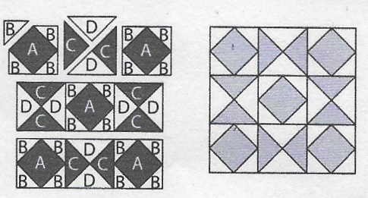
JULY 2018 –COMBINATION STAR

Cutting Directions:
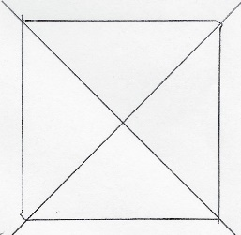
All blocks this year use a ¼ inch seam allowance and will be the same size: 12 ½ x 12 ½ unfinished.
From fabric provided with pattern:
C Fabric: Cut two (2) 5 1/4” squares, cut each twice on the diagonal for 8 pieces
From coordinating fabric:
A Fabric: Cut five (5) 3 3/8” squares (corner & center squares)
From background or coordinating fabric:
B Fabric: Cut ten (10) 2 7/8” squares, cut each once on the diagonal for 20 pieces
D Fabric: Cut two (2) 5 1/4” squares, cut each twice on the diagonal for 8 pieces

Sewing Directions: (refer to diagram on upper left)
- Sew four “B” pieces to each side of the five “A” pieces (corner & center squares)
- Sew two “C” to two “D” pieces, being careful to follow the diagram. Then sew together to form a new square piece. Repeat for 4 squares
- Sew two “A/B” squares to each side of two “C/D” squares to form the top and bottom rows (again, being careful of placement – follow the diagram)
- Sew two “C/D” squares to each side of the center “A/B” square to form the center row
- Sew 3 rows together as noted in the diagram

Congratulations, you’ve finished Block 7 – Combination Star!

