OH MY STARS!
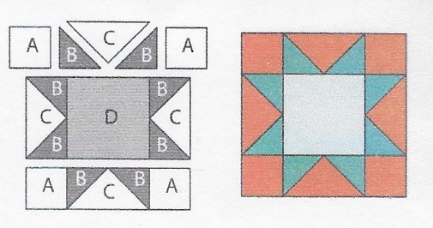
AUGUST 2018 –SAWTOOTH STAR

Cutting Directions:
All blocks this year use a ¼ inch seam allowance and will be the same size: 12 ½ x 12 ½ unfinished.
From fabric provided with pattern:
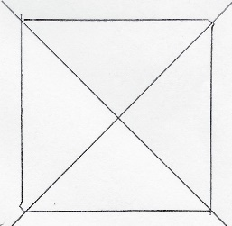
D Fabric: Cut one (1) 6 ½ center square
From Background fabric:
A Fabric: Cut four (4) 3 1/2” squares (corner squares)
C Fabric: Cut One (1) 7 1/4” square, cut twice on the diagonal for 4 pieces
From coordinating fabric:
B Fabric: Cut four (4) 3 7/8” squares, cut each once on the diagonal for 8 pieces
Sewing Directions: (refer to diagram on upper left)
- Sew two “B” pieces to a “C” piece. Repeat for 4 rectangles (outer Flying Geese)
- Sew an “A” corner square piece to each side of two “B/C” Flying Geese rectangles for the top and bottom rows
- Sew a “B/C” Flying Geese rectangle to each side of the middle “D” piece for the middle row
- Following the Sawtooth diagram above, sew the three rows together

Congratulations, you’ve finished Block 8 – Sawtooth Star!

