OH MY STARS!!
JANUARY 2018 – OHIO STAR
All blocks this year use a ¼ inch seam allowance and will be the same size: 12 ½ x 12 ½ unfinished.
The January, 2018 is OHIO STAR, one which we are sure many of you have used before!
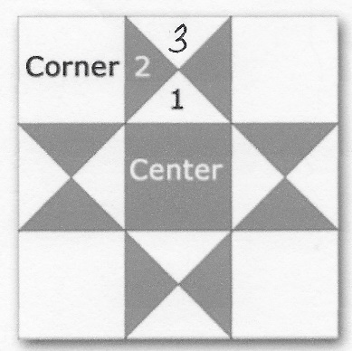

Cutting Directions:
From fabric provided with pattern:
Center Fabric: Cut one (1) 4 ½ square from fabric provided
From Background fabric:
Corner Fabric: Cut four (4) 4 ½ squares
NOTE: for pieces 1, 2 & 3 you have a design choice to make.
- You can use the same fabric for 1 & 3
- You can use different fabrics for 1 & 3 (one coordinating, one background)
- You can use the same fabric for 1 & 2 and a different fabric (background or coordinating) for 3, and this would give you a stronger “star” look for the block
From coordinating fabric:
1: Cut one (1) 5 ¼ square, then cut into quarters
2: Cut two (2) 5 ¼ squares, then cut into quarters
3: Cut one (1) 5 ¼ square, then cut into quarters
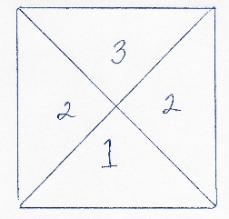
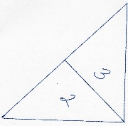
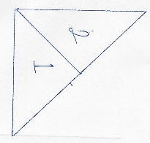
Sewing Directions: (Press as you finish each seam)
Step 1:
- Sew piece 1 to piece 2
- Sew piece 3 to the second piece 2 to create a star square
- Repeat for three other sides
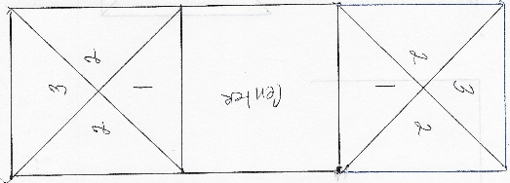
Step 2:
- Sew a star square to one side of the Center square
- Sew a second star square to the opposite side of the Center square
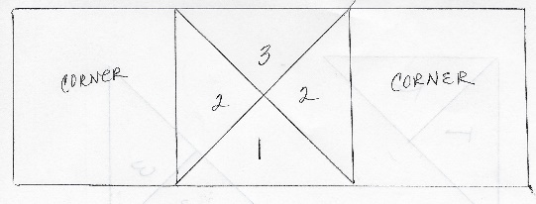
Step 3:
- Sew corner squares to each side of a star square
- Repeat for last star square

Step 4:
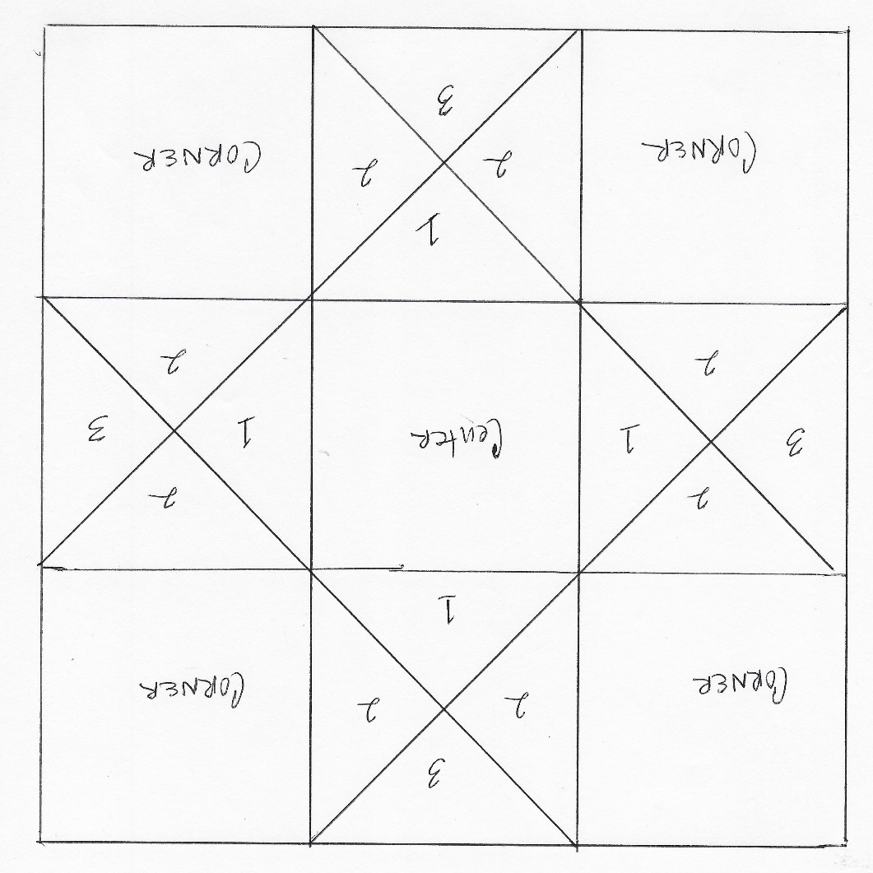
- Sew the three sections together

Congratulations, you’ve finished Block 1 – Ohio Star

