OH MY STARS!
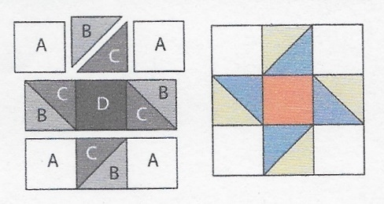
APRIL 2018 – SPINNING STAR

Cutting Directions:
All blocks this year use a ¼ inch seam allowance and will be the same size: 12 ½ x 12 ½ unfinished.
From fabric provided with pattern (Center Square):
D Fabric: Cut One (1) 4 1/2” square from fabric provided
From Coordinating fabric:
B Fabric: Cut two (2) 4 7/8” squares
C Fabric: Cut two (2) 4 7/8” squares
From Background fabric:
A Fabric: Cut four (4) 4 1/2” squares (corner squares)
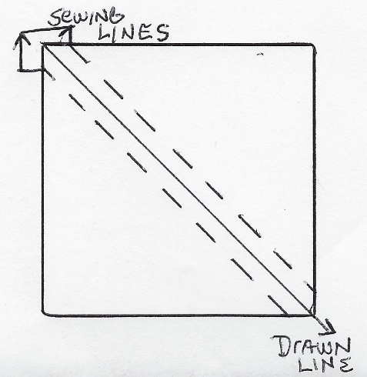
Sewing Directions:
Refer to the February BOM Instructions for creating Half Square Triangles. Refer to the diagram on the right for a reminder.
- Pair two “B” squares with two “C” squares to create the four side center squares
- Following the Spinning Star diagram above, sew 3 squares for each row
- Sew the 3 rows together

Congratulations, you’ve finished Block 4 – Spinning Star!

